# MLOPs Fundamental CICD with Azure DevOps

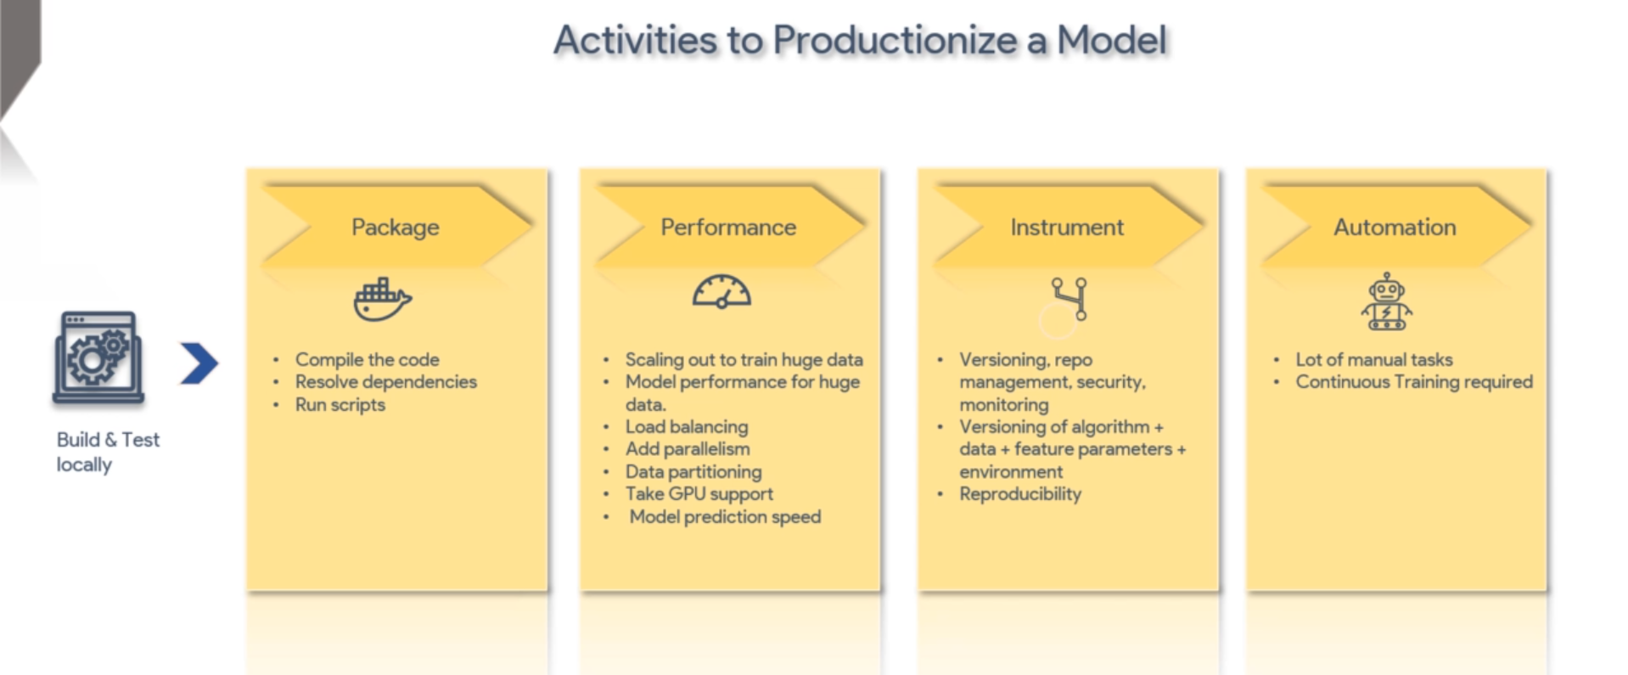

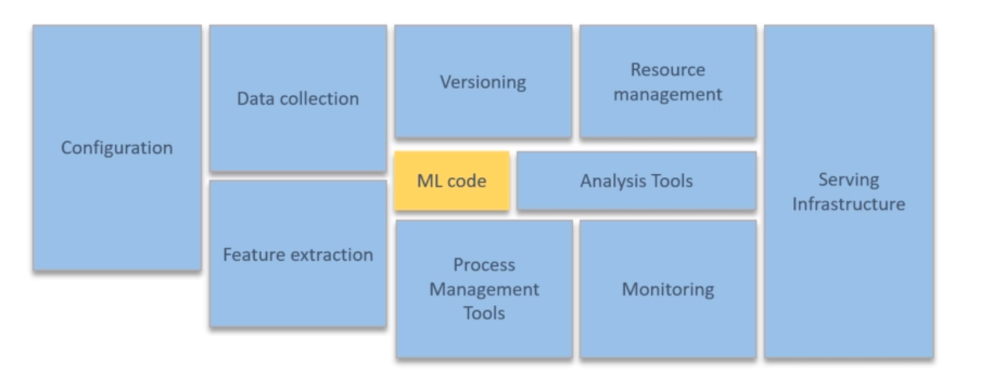

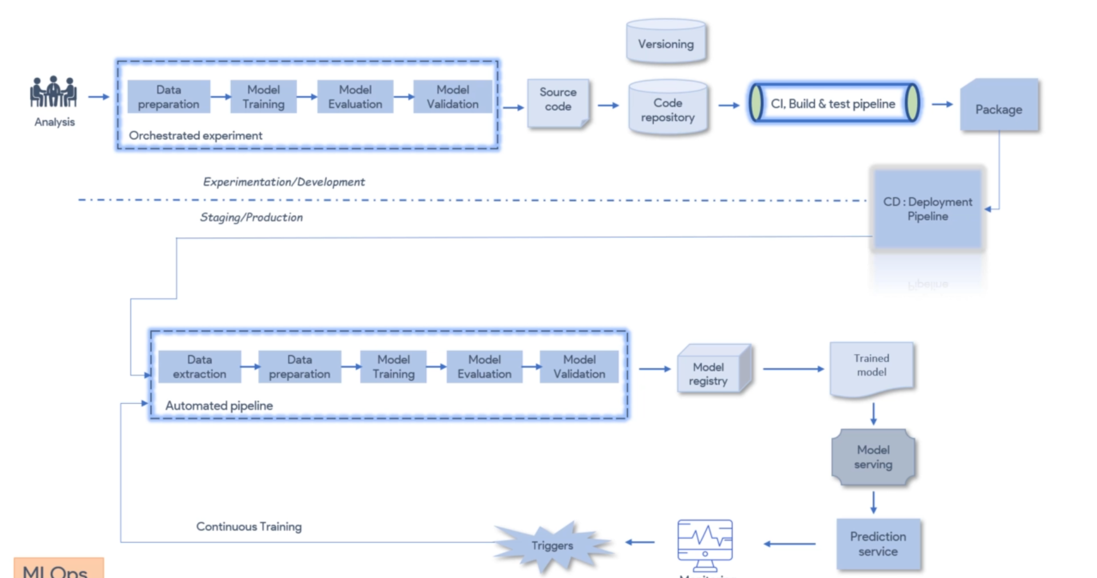

Continuous integration, delivery and training = MLOps

Monitor : Graphana , Prometheus

